**Introduction:**

**Problem Addressed:**

We mostly play shut the box game but now a days as everything is becoming technological advance so it is preferable that we should convert this game digitally to increase its productivity and efficiency rather than relying on that old method of playing. This project which is named as Shut the box project is the implementation of real world game which is very common and famous. In this project, we have to make the circuit which can implement the Shut the box game using digital logic components like decoder, flip flops, memory, 7segments and many other sequential and combinational logic circuits.

This project is very cost effective and user friendly as there is no need to use any type of programmable device like controller is used and no LCDS are used which make the device costly. This project is completed on digital software and every file contains its own specific working. The files contains memory section, input section, decoder section, win state, and in last but not least the Display section. And these all sections forms the shut the box after combining. And this strategy is well powered over others because we can test and find fault easily in specific file. This project is designed for single user but we can add some modifications in it and enhance the working of the project. For this project the knowledge of digital knowledge like flip flops, combinational circuits and seqencial circuit is needed.

**Working of shut the Box Game:**

Overall, this game ca be played by 4 members or 2 members or 1 individual can also play. Basically, this game contains 9 or 12 numbers in front of the player and it also has 2 dices to roll. First of all, the player rolls the dice, counts the number on the dices and according to these numbers he flips numbers. Then again he rolls dices and flips numbers according to it this process repeats. At last the numbers on his dice or their sum cannot match with the remaining unflipped numbers and at this point game terminated and remaining unfliped numbers are the score for the player. The player with lesser score will win.

**Working of the Project:**

The working of the project is that in the first the dice ae rolled and after these dice rolls the numbers on the dices should be added and according to those numbers the numbers should be flipped and these numbers stored in the memory that which number is flipped and which is unflipped after that the dice rolled again and again numbers are flipped and their sum is calculated and according to that the numbers are flipped and saved in the memory and in the same time these flipped and unflipped numbers are shown on the seven segments also. The decoders are used to take data from the memory and shown those on the seven segment display. After the last roll of the dice when the sum cannot flip numbers any more then at this time the unfliped numbers added and then the sum is shown on the seven segments. The one RGB Led shows the status of the game either the game is in progress, either we can play our dice values. Or game has been ended and others things by changing its color like green yellow red and purple.

**Components Used:**

**Decoder:**

A **Digital Decoder** IC, is a device which converts one digital format into another and one of the most commonly used devices for doing this is called the Binary Coded Decimal (BCD) to 7-Segment Display Decoder.

Typically [7-segment displays](https://www.electronics-tutorials.ws/blog/7-segment-display-tutorial.html) consist of seven individual coloured LED’s (called the segments), within one single display package. In order to produce the required numbers or HEX characters from 0 to 9 and A to F respectively, on the display the correct combination of LED segments need to be illuminated and **BCD to 7-segment Display Decoders** such as the 74LS47 do just that.



These are the decoder which we have added in our project these decoder take values and show on the 7 segment display. Each decoder is for one 7 segment

**Seven Segment Display:**

The 7-segment display, also written as “seven segment display”, consists of seven LEDs (hence its name) arranged in a rectangular fashion as shown. Each of the seven LEDs is called a segment because when illuminated the segment forms part of a numerical digit (both Decimal and Hex) to be displayed. An additional 8th LED is sometimes used within the same package thus allowing the indication of a decimal point, (DP) when two or more 7-segment displays are connected together to display numbers greater than ten.

Each one of the seven LEDs in the display is given a positional segment with one of its connection pins being brought straight out of the rectangular plastic package. These individually LED pins are labelled from a through to g representing each individual LED. The other LED pins are connected together and wired to form a common pin.

So by forward biasing the appropriate pins of the LED segments in a particular order, some segments will be light and others will be dark allowing the desired character pattern of the number to be generated on the display. This then allows us to display each of the ten decimal digits 0 through to 9 on the same 7-segment display.

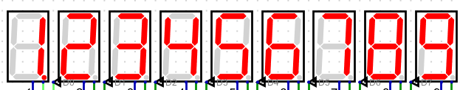

These seven segments show the numbers from 1 to 9 which we have to flip. Similarly the random numbers from dice are also shown on seven segment.

**Logic Gates:**

**XOR gate:**

XOR gates is also used in this this project. The property of the XOR is that it is mostly used in adder circuit and for other purposes also.

[XOR ANSI Labelled.svg](https://en.wikipedia.org/wiki/File:XOR_ANSI_Labelled.svg)

This is the picture of the XOR. Its output will be 1 when both inputs are different otherwise it will be zero.

**XNOR gate:**

XNOR gates is also used in this this project. The property of the XOR is that it is mostly used as universal gate.

XNOR ANSI Labelled.svg

This is the picture of the XNOR. Its output will be 1 when both inputs are same otherwise it will be zero.

**OR gate:**

OR gates is also used in this this project. The property of the OR is that it is mostly used in simple logics.

OR ANSI Labelled.svg

This is the picture of the OR. Its output will be 1 any inputs are is 1 otherwise it will be zero.

**AND gate:**

AND gates is also used in this this project. The property of the AND is that it is mostly used as universal gate.

AND ANSI Labelled.svg

This is the picture of the AND. Its output will be 1 when both inputs are 1 otherwise it will be zero.

**Multiplexer:**

In [electronics](https://en.wikipedia.org/wiki/Electronics), a multiplexer (or mux; spelled sometimes as multiplexor), also known as a data selector, is a device that selects between several [analog](https://en.wikipedia.org/wiki/Analog_signal) or [digital](https://en.wikipedia.org/wiki/Digital_signal_(electronics)) input signals and forwards the selected input to a single output line. The selection is directed by a separate set of digital inputs known as select lines. A multiplexer of {\displaystyle 2^{n}} inputs has {\displaystyle n} select lines, which are used to select which input line to send to the output.

**Demultiplexer:**

DEMUX are used to implement general-purpose logic systems. A demultiplexer takes one single input data line and distributes it to any one of a number of individual output lines one at a time. Demultiplexing is the process of converting a signal containing multiple analog or digital signals backs into the original and separate signals. A demultiplexer of 2^n outputs has n select lines.

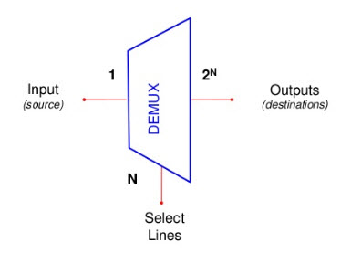

**Subsections of the projects:**

**Display section:**

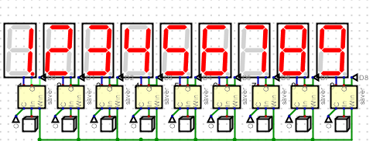

This section is responsible to take inputs like 1,2,3 till 9 and displays on the 7 segments. This section contains decoders, 7 segments as well as the buttons to flip the seven segments. If we want to flip ant number we press the button below it and its flipped.

**Random number generation on seven segment:**

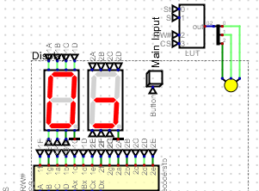

This circuit creates the random numbers on the 7 segments and actually these circuit is doing the work of dice which always produces random number. Apart from these random numbers the RGB led is also shown in this project which shows the status of the game. Like green shows game has started, yellow shows the game in progress and red also show a status and in last purple shows end of game.

**COST and Estimation of the project:**

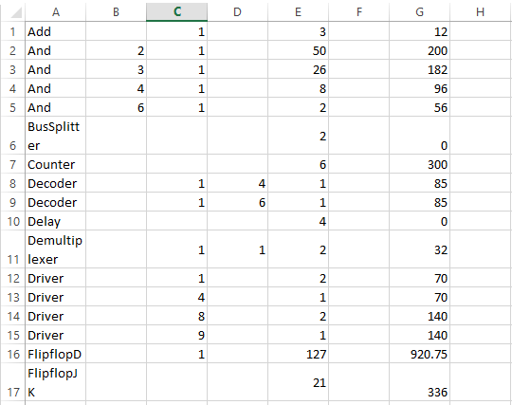

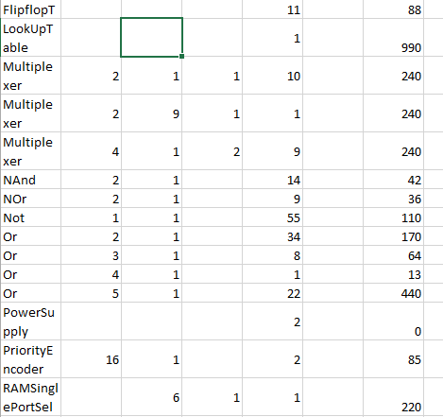

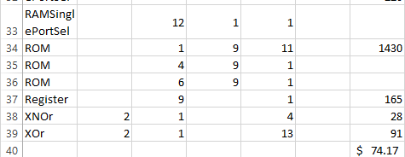

**Conclusion:**

The conclusion of the project is that the circuit has been implemented and the cost estimation is very economical from any other in the market. This circuit can be improved and further enhanced by adding some improvements and by doing some modifications like creating capacity for 2 or 4 players and the numbers in the box can be increased from 9 to 12.so by these little modifications this project can be used commercially as well as this project is done in such a way that further enhancements are possible.